R2 Clowfare Document

1. `sudo apt-get update`
2. `sudo apt-get install python3-pip`

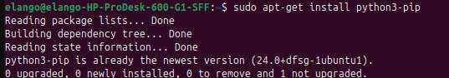

1. `python3 -m venv awscli-env` && `source awscli-env/bin/activate`



1. `pip install awscli`

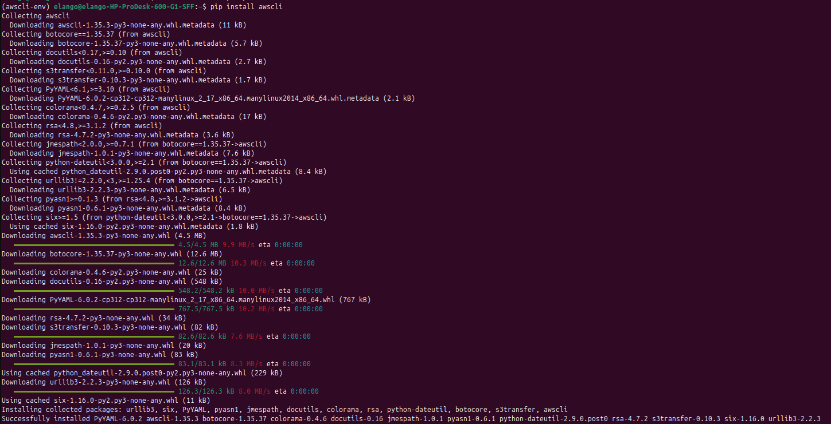

1. `aws --version`



1. `aws configure`

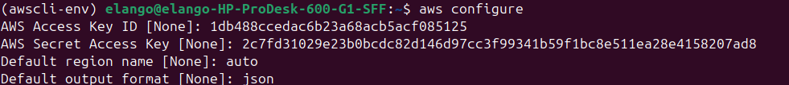

1. For list the bucket files  
   `aws s3 ls s3://suiteny --endpoint-url [https://9cc95721357e7bd2ba149038357744fd.r2.cloudflarestorage.com](https://9cc95721357e7bd2ba149038357744fd.r2.cloudflarestorage.com/)`

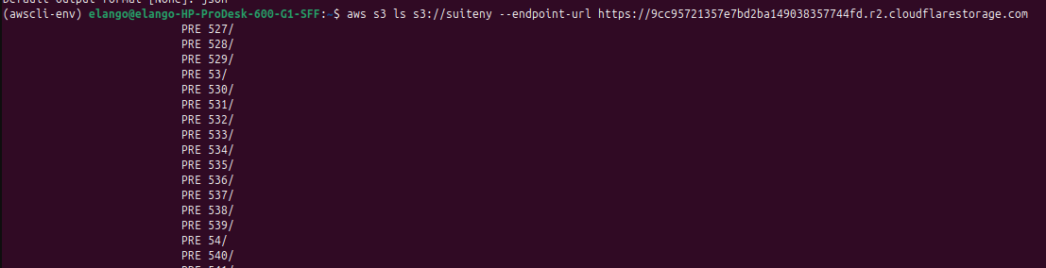

1. For delete the bucket entire files

`aws s3 rm s3://suiteny --recursive --endpoint-url [https://9cc95721357e7bd2ba149038357744fd.r2.cloudflarestorage.com](https://9cc95721357e7bd2ba149038357744fd.r2.cloudflarestorage.com/)`   
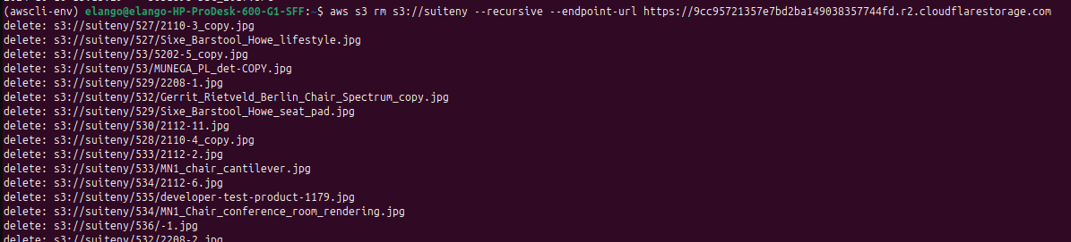

1. For Deactivate  
     
   `deactivate`

### **Given the provided credentials for your Cloudflare R2 storage, you can proceed with configuring your AWS CLI and manage your bucket.**

### 1. **Configure AWS CLI for Cloudflare R2**

Run the following command to configure the AWS CLI with your R2 credentials:

bash

Copy code

aws configure

Enter the following details when prompted:

* **AWS Access Key ID**: 1db488ccedac6b23a68acb5acf085125
* **AWS Secret Access Key**: 2c7fd31029e23b0bcdc82d146d97cc3f99341b59f1bc8e511ea28e4158207ad8
* **Default region name**: auto
* **Default output format**: (leave it blank or type json)

### 2. **Set the Endpoint URL**

When performing AWS CLI commands for Cloudflare R2, you need to include the --endpoint-url option with your R2 endpoint:

For example, if you want to list the contents of your bucket:

bash Copy code

*aws s3 ls s3://suiteny --endpoint-url https://9cc95721357e7bd2ba149038357744fd.r2.cloudflarestorage.com*

### 3. **Remove All Objects in the Bucket**

To empty the suiteny bucket, you can use the rm command with the --recursive option as follows:

bash

Copy code

aws s3 rm s3://suiteny --recursive --endpoint-url https://9cc95721357e7bd2ba149038357744fd.r2.cloudflarestorage.com

This command will delete all objects in the bucket.

### 4. **Verify the Bucket is Empty**

After running the above command, you can list the contents of the bucket to ensure it's empty:

bash

Copy code

aws s3 ls s3://suiteny --endpoint-url https://9cc95721357e7bd2ba149038357744fd.r2.cloudflarestorage.com

Let me know if you encounter any issues or need further assistance!